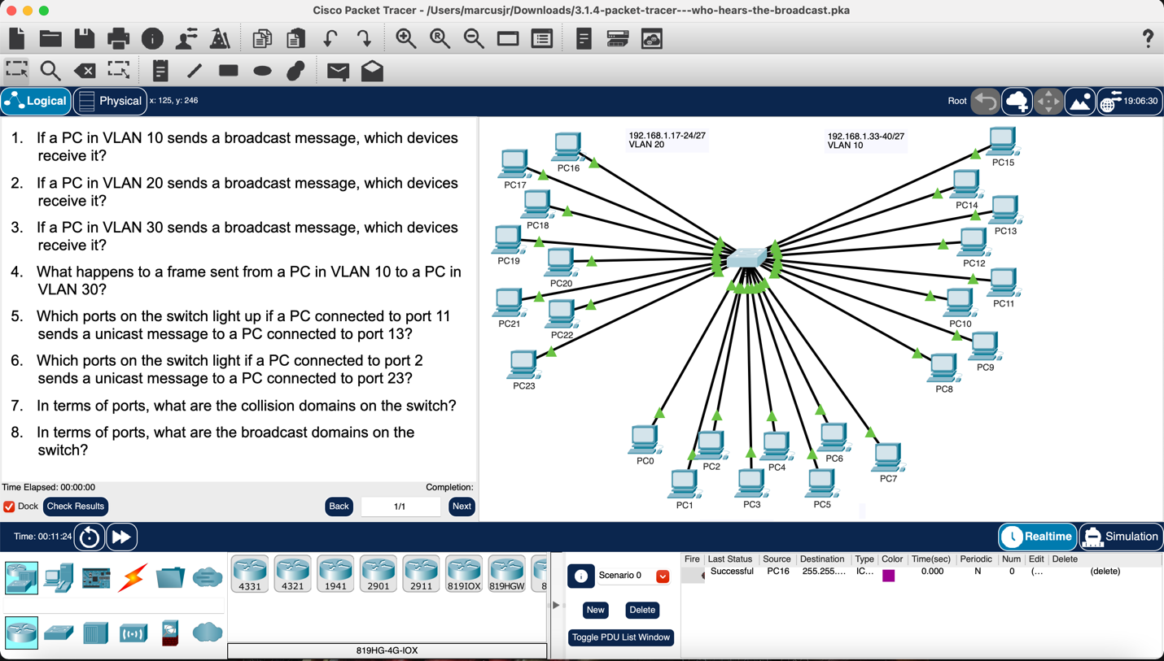

1. All the PCs/devices in VLAN 10
2. All the PCs/devices in VLAN 20
3. All the PCs/devices in VLAN 30
4. The message would get lost because it is not sending the message in VLAN 10
5. Ports 11 & 13
6. The frame would be dropped because the VLAN is different
7. Each port is its own collision domain
8. There are 3 broadcast domains, each VLAN is its own broadcast domain.

